Design and Development of a Solar-Powered Smart Coastal Observation Buoy with a Shore-Based Bay Station for Pressure-Derived Wave Monitoring and AI-Assisted Short-Term Prediction
Prepared by: Project FALCON Research Group — Bachelor of Science in Information Technology, Fullbright College
October 2026 (first draft; proposal stage — hardware integration and field validation pending)

CHAPTER 1 — INTRODUCTION

1.1 Background of the Study
Coastal waters support transportation, fisheries, tourism, environmental protection, and disaster preparedness, and millions of Filipinos depend on daily decisions about sea conditions. Reliable, site-specific marine observations therefore have clear public value. Commercial observation buoys exist and perform well, but their acquisition, maintenance, and operating costs place them beyond the reach of most local government units, schools, and coastal organizations. At the same time, recent advances in microcontrollers, long-range low-power telemetry, solar energy systems, and machine learning have made it feasible for a student research team to design, build, and evaluate an affordable coastal observation platform. Project FALCON (Fullbright College’s AI-powered Live Coastal Observation Network) is proposed as such a platform: a solar-powered smart coastal observation buoy paired with a shore-based Bay Station, intended to estimate wave conditions from underwater-pressure variation, observe local wind, and research short-term wave prediction as an undergraduate development study. This chapter presents the background of the study in international, national, and local contexts, reviews related literature and studies, states the conceptual framework, significance, problem, scope, and key terms.
STATUS NOTE (proposal stage). This draft describes a proposed system. No pressure sensor has been purchased, no field deployment has been conducted, and no accuracy claim is made. Wave height in this study is an ESTIMATED quantity derived from measured pressure, and every dashboard value remains labeled MEASURED, ESTIMATED, PREDICTED, SIMULATED, STALE, or UNAVAILABLE with CALIBRATION REQUIRED until reference validation is complete.

1.1.1 International Context
Globally, sustained ocean observation underpins maritime safety, weather analysis, and climate assessment, yet dense near-shore coverage remains uneven because professional instruments are costly to buy and maintain. Commercial wave buoys such as the Datawell Directional Waverider and NexSens modular platforms provide accurate wave and environmental measurements and serve as professional benchmarks, but they are intended for government agencies and large research institutions (see Section 1.3). This cost barrier has motivated a worldwide stream of low-cost buoy research. Albaladejo et al. (2012) demonstrated that a compact wireless-sensor buoy can support shallow-marine monitoring when affordability, stability, acquisition, communication, and autonomous power are designed as one system. Zhang et al. (2020) presented an integrated solar-powered buoy linked to a shore-based system, showing the importance of deliberate sensor integration and power design. More recently, Williams et al. (2025) reported a compact autonomous platform for current and seawater-parameter observation, reinforcing that modular, reproducible student-scale buoys are feasible.
On measurement science, the international literature is consistent on two points that shape this study. First, buoys do not observe the sea surface directly; they infer it through platform motion and sensor response, so hull response, mooring, transfer functions, and noise affect every result (Ardhuin et al., 2019; Thomson et al., 2018). Second, subsurface pressure can be converted to surface elevation only with documented treatment of sensor depth, frequency-dependent attenuation, and nonlinearity (Bishop & Donelan, 1987; Bonneton et al., 2018; Martins et al., 2022). The international context therefore supports the project’s direction while imposing its central discipline: an affordable buoy may estimate wave statistics, but only calibration against an independent reference turns readings into defensible measurements.

1.1.2 National Context
The Philippines is an archipelagic nation of more than 7,600 islands whose coastal waters carry fishing, inter-island transport, tourism, and disaster-response activity. The Philippine Atmospheric, Geophysical and Astronomical Services Administration (PAGASA) is mandated to improve weather and sea-condition analysis, wave forecasting, and marine warnings, while the National Mapping and Resource Information Authority (NAMRIA) maintains tide stations and provides tidal and oceanographic information (PAGASA, n.d.; NAMRIA, 2025). These national functions establish the public importance of marine observation.
National capability does not, however, reach every shoreline. Many local government units, public schools, and coastal organizations have no site-specific instrument of their own and cannot fund commercial buoys. A locally built, low-cost, maintainable observation buoy therefore addresses a recognizable national need: affordable instruments that barangays, campuses, and small research groups can deploy, understand, and repair. Consistent with this role, Project FALCON is framed strictly as a research and local decision-support prototype; it does not replace PAGASA forecasts, coast guard instructions, navigation equipment, or official emergency-warning systems.

1.1.3 Local Context
This study is undertaken as an undergraduate capstone project of the Bachelor of Science in Information Technology program of Fullbright College by the Project FALCON Research Group. The intended pilot setting is a near-shore barangay coastline where a moored buoy reports to a gateway housed in the barangay hall, and where the intended dashboard readers include older or non-technical operators such as fisherfolk leaders and barangay staff. That audience shapes concrete design choices carried through the whole study: four dashboard pages (Overview, Buoy Motion, Sensors, Logs & Alerts), large text, plain labels, and explicit source and freshness states on every value.
The local context also fixes the deployment boundaries used in Chapter 2. The buoy carries an ESP32 controller, approved sensors, LoRa telemetry, power, and security electronics, with no mini-PC and no cellular modem on the water. Storage, processing, prediction, dashboard hosting, and alerts run on the shore Bay Station, whose separate SIM/4G/5G connection serves only as Internet backhaul, so local monitoring continues during Internet interruption.

1.2 Review of Related Literature
This section synthesizes concepts and findings thematically from the project’s Review of Related Literature (Project_FALCON_RRL.docx, August 2026). Full discussion and the complete reference list appear in that record; what follows are the conclusions that directly justify design decisions in this proposal.
Low-cost and autonomous marine platforms. The reviewed platforms show that physical design cannot be separated from information-system design: hull geometry, ballast, freeboard, mooring, antenna placement, cable entry, enclosure temperature, and solar exposure all influence the quality of the data that eventually reach the dashboard (Albaladejo et al., 2012; Zhang et al., 2020; Williams et al., 2025). FALCON therefore treats the buoy, power, communication, and software as one evaluation unit, following the integrated-evaluation principle also seen in marine battery-IoT work (Cho et al., 2021). Because low cost and sensor integration alone are well established, this study claims no novelty in building a buoy; its intended contribution is the documented integration and local evaluation of sensing, telemetry, shore processing, solar power, security telemetry, and transparent prediction research.
Motion-based and pressure-assisted wave measurement. Strapdown inertial sensing can yield wave information through orientation estimation, coordinate transformation, integration, and spectral analysis (Zhou et al., 2022), but raw vertical acceleration must never be labeled as wave height: gravity removal, bias, filtering, integration drift, sampling rate, synchronization, buoy response, and mooring all intervene (Ardhuin et al., 2019; Thomson et al., 2018). Pressure sensing offers an independent path, yet pressure is likewise not surface elevation until compensated; reconstruction quality depends on depth, frequency, nonlinearity, and the transfer formulation (Bishop & Donelan, 1987; Bonneton et al., 2018; Martins et al., 2022). The study therefore defines its Phase 1 wave output as estimated significant wave height (Hs) over a stated window — a term that can be defined, aggregated, compared, and predicted consistently — and requires tank and near-shore comparison against an independent reference (staff gauge, synchronized video, reference logger, acoustic gauge, or validated instrument) before any accuracy claim.
Solar energy, edge computing, and data quality. Marine autonomy is an energy balance among sensing, computation, communication, harvesting, and storage, best handled with degradation awareness and power-saving strategies (Cho et al., 2021; Grare et al., 2021; Wiranata & Widodo, 2026). The literature supports FALCON’s division of work — deterministic acquisition, timestamping, buffering, and health checks on the ESP32; storage, processing, dashboard, and inference on shore power — provided it is validated by a measured load table and daily energy budget rather than component ratings. Because calibration drift, corrosion, limited energy, unreliable links, and missing references persistently degrade ocean-sensor data (Skålvik et al., 2023), every record in this study carries time validity, sensor-health information, and quality flags, and prediction is withheld or marked unreliable when required inputs fail checks.
Coastal communications and position monitoring. Practical marine telemetry must assume interruption: local storage, sequence numbers, retry logic, duplicate handling, and delayed synchronization are required rather than an always-on link. LoRa suits the low-rate buoy-to-shore path with a local gateway, while SIM/4G/5G serves as backhaul; identity authentication and duplicate prevention are part of the design (see also the open LoRa-buoy preprint, Dreyer et al., 2026, treated here as not yet peer-reviewed). Position monitoring for geofence and tamper logic must tolerate GPS scatter through persistence rules so that ordinary motion is not reported as theft (Raja Ali et al., 2026).
Short-term wave prediction. Machine-learning wave prediction is an active field: LSTM-based significant-wave-height models (Fan et al., 2020), decomposition-plus-deep-learning hybrids (Song et al., 2023), and comprehensive surveys of the field (Mo et al., 2024) all show that models can add value — but only against stated baselines on chronologically separated data. This study therefore freezes one primary target (recommended: 10-minute-ahead estimated Hs), builds persistence and moving-average baselines first, splits data chronologically by deployment block or day, and reports MAE, RMSE, bias, and skill relative to persistence on untouched test data.
Dashboards and usability. Because the intended readers include non-technical operators, dashboard design follows plain-label, large-text, explicit-state practice for older and non-technical users (Mohammadi et al., 2024): four fixed pages, GPS grouped under Supporting Telemetry, Settings as a compact header control, and every value labeled by source and freshness. Values shown in simulator mode are software demonstrations, never field measurements.

1.3 Review of Related Studies
Existing systems fall into two groups, and neither closes the gap this study addresses. Commercial wave buoys (Datawell Directional Waverider, NexSens platforms) measure accurately but are expensive, proprietary, and aimed at professional institutions. Typical low-cost academic prototypes (ESP32/Arduino/Raspberry Pi builds, including IoT water-quality networks) demonstrate real-time acquisition and display but stop at data collection and visualization, rarely adding calibrated wave estimation, autonomous power validation, or prediction evaluated against baselines.
Table 1. Comparison of existing systems and Project FALCON.
Feature | Commercial Wave Buoys | Typical Low-Cost Prototypes | Project FALCON (Proposed)
Real-time monitoring | Yes | Yes | Yes (proposed)
Solar-powered autonomy | Yes | Some | Yes, to be measured
Open-source hardware | No | Yes | Yes
Low cost / locally maintainable | No | Yes | Yes (design goal)
Calibrated wave estimation | Yes | Rare | Proposed; pending validation
AI-assisted wave analysis | Rare | Rare | Proposed; vs. baselines
Local web dashboard | Limited | Some | Four pages (proposed)
Designed for PH shore deployment | No | Limited | Yes (design goal)
The comparison yields the research gap: no reviewed affordable platform combines, in one documented and locally maintainable build, a stable floating platform, autonomous solar-powered operation, timestamped LoRa telemetry with outage recovery, shore-based processing and storage, calibrated pressure-derived wave estimation, transparent short-term prediction tested against non-AI baselines, and a dashboard usable by non-technical operators. Studies that attempt many parameters at once further pay for breadth with complexity, cost, calibration load, and maintenance effort; FALCON deliberately narrows Phase 1 to pressure-derived wave sensing plus wind speed and direction as the primary measurements, with GPS, power, timestamps, and security states as supporting telemetry, and water temperature and other environmental sensors excluded.
Project FALCON addresses the gap as an integration-and-evaluation study rather than an invention claim. It does not propose a new sensor or a new AI algorithm; it proposes to combine established components into one reproducible near-shore research platform and to test, honestly and traceably, whether that platform measures, communicates, powers itself, alerts sensibly, reads clearly, and predicts better than persistence.

1.4 Theoretical and Conceptual Framework
The study is guided by an Input–Process–Output (IPO) framework. The input layer consists of direct pressure and wind observations together with supporting GPS, power, security, and health telemetry. The process layer consists of ESP32 acquisition (timestamping, validation, framing, buffering), the LoRa transport link to the barangay-hall gateway, and the shore Bay Station services (authentication, deduplication, storage, processing, prediction, alerts, API). The output layer consists of retained records, derived wave statistics, predictions, and operator messages, closed by evaluation evidence that determines whether each output is accurate, reliable, usable, and safe within the stated scope.
[FIGURE PLACEHOLDER] Figure 1. Input–Process–Output conceptual framework (to be inserted; same framework as Chapter 2, Figure 1).
The framework enforces one theoretical rule across all chapters: no stage may impersonate another. What is measured (pressure, wind) is reported as MEASURED; what is derived (wave height) is reported as ESTIMATED; what the model produces is PREDICTED; what the simulator produces is SIMULATED; and anything uncalibrated is flagged CALIBRATION REQUIRED. This separation is the study’s answer to the established caution that every observing platform and processing method carries its own response and uncertainty (Ardhuin et al., 2019).

1.5 Significance of the Study
Coastal residents and fisherfolk. A readable, site-specific display of current wave estimates, wind observations, and system freshness helps daily go/no-go judgments at the shoreline. The study contributes decision support only; safety authority remains with PAGASA, the coast guard, and official warnings.
Barangay and municipal (LGU) offices. An affordable, locally maintainable platform with a barangay-hall gateway gives local offices their own near-shore record — useful for incident awareness, planning, and justifying further investment — without dependence on continuous Internet.
Students and Fullbright College. The project demonstrates a complete capstone arc: requirements, architecture, prototype, controlled testing, evaluation, and revision, integrating embedded systems, telemetry, databases, web presentation, renewable energy, and applied machine learning in one artifact the school can exhibit and extend.
Researchers and future developers. Versioned firmware, schema, calibration coefficients, chronological evaluation protocol, and published limitations give the next team a traceable baseline instead of a black box, including explicit negative results if any subsystem fails its acceptance test.

1.6 Statement of the Problem
General problem. This study designs and develops Project FALCON, a solar-powered smart coastal observation buoy with a shore-based Bay Station, capable of pressure-derived wave monitoring and AI-assisted short-term wave height prediction using a focused set of IoT sensors, and evaluates whether the integrated platform meets defined acceptance criteria for measurement, communication, power, alerting, usability, and prediction.
Specifically, this study seeks to answer the following questions:
1. How accurately and repeatably can calibrated underwater-pressure variation estimate the selected wave-height statistic during controlled trials?
2. How reliably can the ESP32–LoRa–Bay Station path deliver timestamped records and recover from link or Internet outages without silent data loss or duplication?
3. Can the solar-battery subsystem sustain the required buoy operating schedule under measured load and reduced-sun conditions?
4. How effectively can persistent geofence and enclosure/tamper rules identify abnormal events without treating ordinary motion or GPS scatter as theft?
5. Can older or non-technical operators understand the four-page dashboard and complete essential monitoring tasks with minimal assistance?
6. Does the selected AI method improve on non-AI baselines for one defined short-term wave-height target on chronologically held-out calibrated data?
These six questions map one-to-one onto the methodological instruments of Chapter 2, Table 1 (sensor-reference comparison; LoRa/backhaul scenarios; instrumented power logging; controlled false-alert scenarios; task-based usability testing; chronological hold-out against persistence baselines).

1.7 Scope and Delimitations; Definition of Terms
TEMPLATE NOTE. Section 1.7 in REVISED-CAPSTONE-IT_CS-PROPOSAL_4 repeats the title of 1.4 (Theoretical and Conceptual Framework). Following standard IT/CS proposal practice, 1.7 is written here as Scope and Delimitations plus Definition of Terms. Confirm this reading with the adviser before final submission.

Scope and Delimitations
The study covers the design, prototype implementation, controlled testing, and evaluation of one solar-powered buoy node and one shore Bay Station for near-shore research use. Primary Phase 1 measurements are pressure-derived wave sensing and wind speed/direction; GPS, power, timestamps, and security states are supporting telemetry. The deployment pressure candidate is the Holykell HPT604 Type A (provisional 0–2 mH2O vented gauge, 4–20 mA), pending written supplier confirmation of continuous-saltwater suitability and calibration; a bench-only Bar02 sensor is used solely for supervised bench comparison. Final LoRa radio, gateway, antenna, band, protocol, and Bay Station computer are selection gates documented in the selection register. The study excludes continuous open-sea deployment, official forecasting or warnings, water-temperature/salinity/chemistry sensing, and any claim of accuracy before reference validation. All energy figures prior to instrumented logging are calculations, not measurements; all simulator outputs are workflow demonstrations, not field evidence.

Definition of Operational Terms
MEASURED. A value read directly from a calibrated sensor channel (e.g., underwater pressure, wind speed).
ESTIMATED. A value derived from measured quantities through documented processing (e.g., significant wave height from pressure); labeled ESTIMATED and CALIBRATION REQUIRED until reference validation is complete.
PREDICTED. The output of the AI short-term model for a frozen target (recommended: 10-minute-ahead estimated Hs); withheld when inputs are invalid, stale, or uncalibrated.
SIMULATED. Software-generated values used to demonstrate workflow; never field evidence.
Significant wave height (Hs). The defined primary wave statistic: the mean of the highest third of waves over a stated window, estimated from pressure in this study.
Bay Station. The shore-based service point (proposed: barangay hall) that authenticates, stores, processes, predicts, alerts, and serves the dashboard; its SIM/4G/5G link is Internet backhaul only.
LoRa link. The low-rate buoy-to-shore telemetry path; site range and reliability are selection gates requiring testing.
Persistence baseline. The non-AI reference forecast that future conditions equal current conditions; any AI candidate must beat it on untouched chronological test data to claim value.

CHAPTER 2 — METHODOLOGY

2.1 Research Design / Project Development Methodology
This study employs a developmental research design (design-and-development research) suited to information technology and computer science projects that produce an artifact rather than only test a hypothesis. The research proceeds through iterative cycles of requirements analysis, architectural design, prototype implementation, controlled testing, evaluation, and revision, because a low-cost marine monitoring platform can only be judged when its buoy, sensing, communication, and energy subsystems are engineered and evaluated as one integrated unit (Williams et al., 2025; Rojas et al., 2025).
The study is applied experimental development: the artifact — a solar-powered coastal observation buoy paired with a shore-based Bay Station — is built and then subjected to controlled trials that yield quantitative evidence of measurement quality, communication reliability, power autonomy, security behavior, usability, and short-term prediction accuracy. Consistent with the caution that every observing platform and processing method carries its own response and uncertainty (Ardhuin et al., 2019), the design separates what is measured, estimated, predicted, simulated, stale, and unavailable, so that no stage of the pipeline is allowed to impersonate another.
Both quantitative and qualitative strands are used. Quantitative measurements supply sensor error, communication performance, energy consumption, alert performance, usability task metrics, and prediction error. Qualitative comments gathered from authorized evaluators (advisers, faculty, and identified coastal-community users) capture clarity, comprehension, and maintenance difficulties that numeric indicators alone would not reveal. Development follows an iterative–incremental (agile-inspired) process in which each increment is frozen against a defined objective, tested, and only then carried forward. Table 1 maps the research objectives to their methodological instruments.
Table 1. Alignment of Research Objectives with Methodological Instruments
Specific objective (from Chapter 1) | Methodological instrument (Chapter 2)
Accuracy of pressure-derived wave estimate | Sensor-reference comparison; MAE, RMSE, bias (2.6)
Telemetry reliability and outage recovery | LoRa/backhaul scenarios; packet-delivery metrics (2.6)
Solar-battery autonomy | Instrumented power logging; Wh/day energy budget (2.5–2.6)
Geofence/tamper alert behavior | Controlled false-alert scenarios (2.6)
Dashboard comprehensibility | Task-based usability testing with non-technical participants (2.6)
AI short-term prediction | Chronological hold-out vs. persistence baselines (2.6)

2.2 System Architecture / Framework
The approved architecture follows an Input–Process–Output (IPO) framework (see Figure 1). Direct pressure and wind observations, with supporting GPS, power, security, and health telemetry, form the input layer; the ESP32 acquisition layer, the LoRa transport link, and the shore Bay Station services form the process layer; retained records, derived wave statistics, predictions, and operator messages form the output layer, closed by evaluation evidence that determines whether each output is accurate, reliable, usable, and safe for the stated research scope.
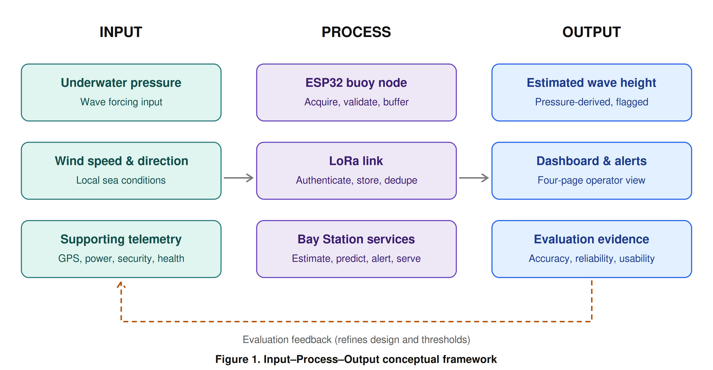
Figure 1. Input–Process–Output conceptual framework
The system is organized into five cooperating layers, each with an explicit responsibility and a defined failure behavior (Table 2). The buoy data is routed through a site-tested LoRa link to a barangay-hall gateway, and SIM/4G/5G is used only as the Bay Station Internet backhaul — never as the buoy direct connection. This separation lets local ingestion, storage, prediction, and dashboard services continue during Internet interruption (see Figure 2), a resilience property emphasized in recent integrated marine-IoT work (Cho et al., 2021; Rojas et al., 2025).
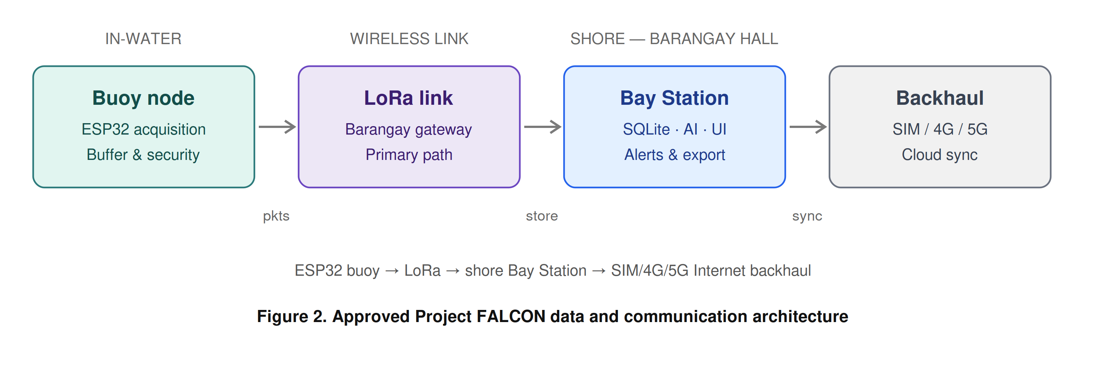
Figure 2. Approved Project FALCON data and communication architecture
Table 2. Approved Project FALCON Data and Communication Architecture
Layer | Responsibility | Failure behavior
Sensors and interfaces | Produce primary pressure/wind signals and supporting telemetry | Report invalid/unavailable states; do not substitute zero
ESP32 buoy node | Acquire, timestamp, validate, frame, secure, transmit, buffer | Continues sensing and local security during LoRa loss
LoRa link | Carry compact packets to the barangay-hall gateway | Triggers buffering and timestamp-preserving retransmission
Bay Station | Authenticate, deduplicate, store, process, predict, alert, serve | Continues local operation during Internet loss
Internet backhaul | Cloud synchronization and authorized remote access only | Queues upload while local services remain available

2.3 Data Collection Methods
Data collection combines primary field data from the deployed prototype with secondary documentary data from datasheets, standards, and official meteorological references.
Primary data. The buoy acquires three classes of data. Underwater pressure is sampled at a rate justified by the target wave band, since pressure-based wave measurement is valid only when attenuation, sensor depth, and frequency response are handled correctly (Meulé et al., 2024; Zhou et al., 2025). Wind speed and direction are acquired through the prototype anemometer/vane assembly, and supporting telemetry — GPS position/time, battery/solar status, enclosure/security state, and system health — is acquired at independent, documented rates. Every record is assigned a station identifier, packet/sequence number, original sample timestamp, firmware/schema version, source label, and quality flags before transmission.
Secondary data. Documentary sources include the pressure-sensor datasheet and immersion guidance (Holykell, n.d.; Blue Robotics, n.d.) and official weather terminology used to frame safety boundaries without implying official forecasting (PAGASA, n.d.).
Reference and calibration instruments. Accurate evaluation requires an independent, time-aligned reference rather than the readings of the system itself. Before controlled trials, the pressure and wind channels are calibrated and the resulting coefficients versioned and recorded. Documentation follows the principle that sensor drift, corrosion, power limits, intermittent communication, and limited references are recurring threats to ocean-sensor data quality; the protocol therefore records metadata, quality flags, and maintenance history alongside raw values (Skålvik et al., 2023).
Data management. A single unified record schema is enforced end-to-end. Out-of-range, stale, disconnected, implausible, and stuck values are flagged or rejected, never silently replaced with zero. During LoRa outages the node buffers a defined duration of records and preserves original timestamps on retransmission; the Bay Station authenticates buoy identity, prevents duplicate insertion, and logs rejected or malformed packets. Data are retained with backups, export capability, and a documented retention rule (Section 2.7).

2.4 Software and Tools Used
The prototype integrates embedded firmware, a shore-side service, a relational database, a web dashboard, and a machine-learning pipeline. Table 3 maps each functional area to the software and tools applied and to its purpose. Following the integrated-evaluation principle of prior marine buoy systems, marine sensing, communication, and battery behavior are treated as one evaluation unit (Cho et al., 2021; Wiranata & Widodo, 2026).
Table 3. Software and Tools Used in Development
Functional area | Software / tool | Purpose
Buoy firmware | ESP32 environment (PlatformIO/Arduino) | Acquisition, timestamping, framing, buffering, LoRa transmission
Shore service | Python (Bay Station service) | Ingestion, validation, deduplication, processing, prediction, API
Database | SQLite | Local storage of original and derived records with version metadata
Dashboard | Responsive web front end (four pages) | Overview, Buoy Motion, Sensors, Logs & Alerts for non-technical operators
API services | REST/grouped endpoint layer | Serve dashboard and export requests; least-privilege access
Prediction | Python machine-learning libraries | Persistence/moving-average baselines and linear, tree-based, GRU, or LSTM candidates
Version control | Git repository | Firmware, schema, algorithm, and model versioning
Mechanical design | CAD software | Buoy geometry, stability, enclosure documentation (reference only pending redesign)

The dashboard navigation is fixed at four pages — Overview, Buoy Motion, Sensors, and Logs & Alerts — with GPS grouped under Supporting Telemetry and Settings kept as a compact header control. Large text, plain labels, and explicit source/freshness states serve older or non-technical operators (Mohammadi et al., 2024). The existing dashboard prototype is shown in Figure 4; any values displayed in simulator mode are not field measurements.

2.5 Development Procedures
Development proceeds through six approval-gated milestones (Table 4), each with a deliverable and an exit-evidence requirement so that no later stage builds on an unverified earlier stage.
Table 4. Development Milestones and Exit Evidence
Milestone | Deliverable | Exit evidence
M1 Scope freeze | Signed architecture, site/use case, wave statistic, AI target | Adviser approval record
M2 Component freeze | Exact BOM, datasheets, pinout, LoRa/Bay Station selection | Selection register complete
M3 Bench integration | Calibrated sensors and packet path | Bench logs and acceptance sheets
M4 Controlled water test | Wave-reference, wind, security, power dataset | Traceable synchronized records
M5 Software evaluation | Dashboard usability and AI baseline/model results | Metrics and held-out evaluation
M6 Final revision | Thesis, presentation, BOM, diagrams, dataset, limitations | Adviser-approved release

Hardware baseline. The pressure channel is the highest-risk component. The deployment candidate is a HPT604 Type A, provisional 0–2 mH2O vented-gauge sensor with 4–20 mA output, interfaced through a protected 12 V loop, a 150 Ω precision shunt, input protection/filtering, and a 3.3 V ADS1115 receiver. Its vent tube must terminate in a dry, breathable, supplier-approved desiccant/breather arrangement, and written confirmation of continuous saltwater compatibility, wetted materials, seals, cable, and exact order code is required before purchase. The bench-only Bar02 I2C sensor is retained only for bench work because its manufacturer restricts continuous immersion (Blue Robotics, n.d.). Final LoRa radio, gateway, antenna, band, and protocol, as well as the Bay Station computer, remain selection gates.
Pressure-to-wave processing procedure. Before implementation is frozen, the researchers define whether the primary output is instantaneous peak-to-trough height, mean height, or significant wave height (Hs). The recommended research output is estimated significant wave height over a stated window, because that term can be defined, aggregated, compared, and predicted consistently. The procedure then freezes sampling frequency, window duration, density assumption, static/tidal removal, filter band, depth-response correction, gap policy, and reference method (Figure 3). Dynamic surface-wave reconstruction requires documented treatment of sensor depth and frequency-dependent attenuation (Meulé et al., 2024; Zhou et al., 2025), with instrument validation against an independent reference as done for encoder/accelerometer wave instruments (Suwardiyanto et al., 2024). All coefficients and revisions are versioned, and where calibration is incomplete the dashboard must display ESTIMATED and CALIBRATION REQUIRED.
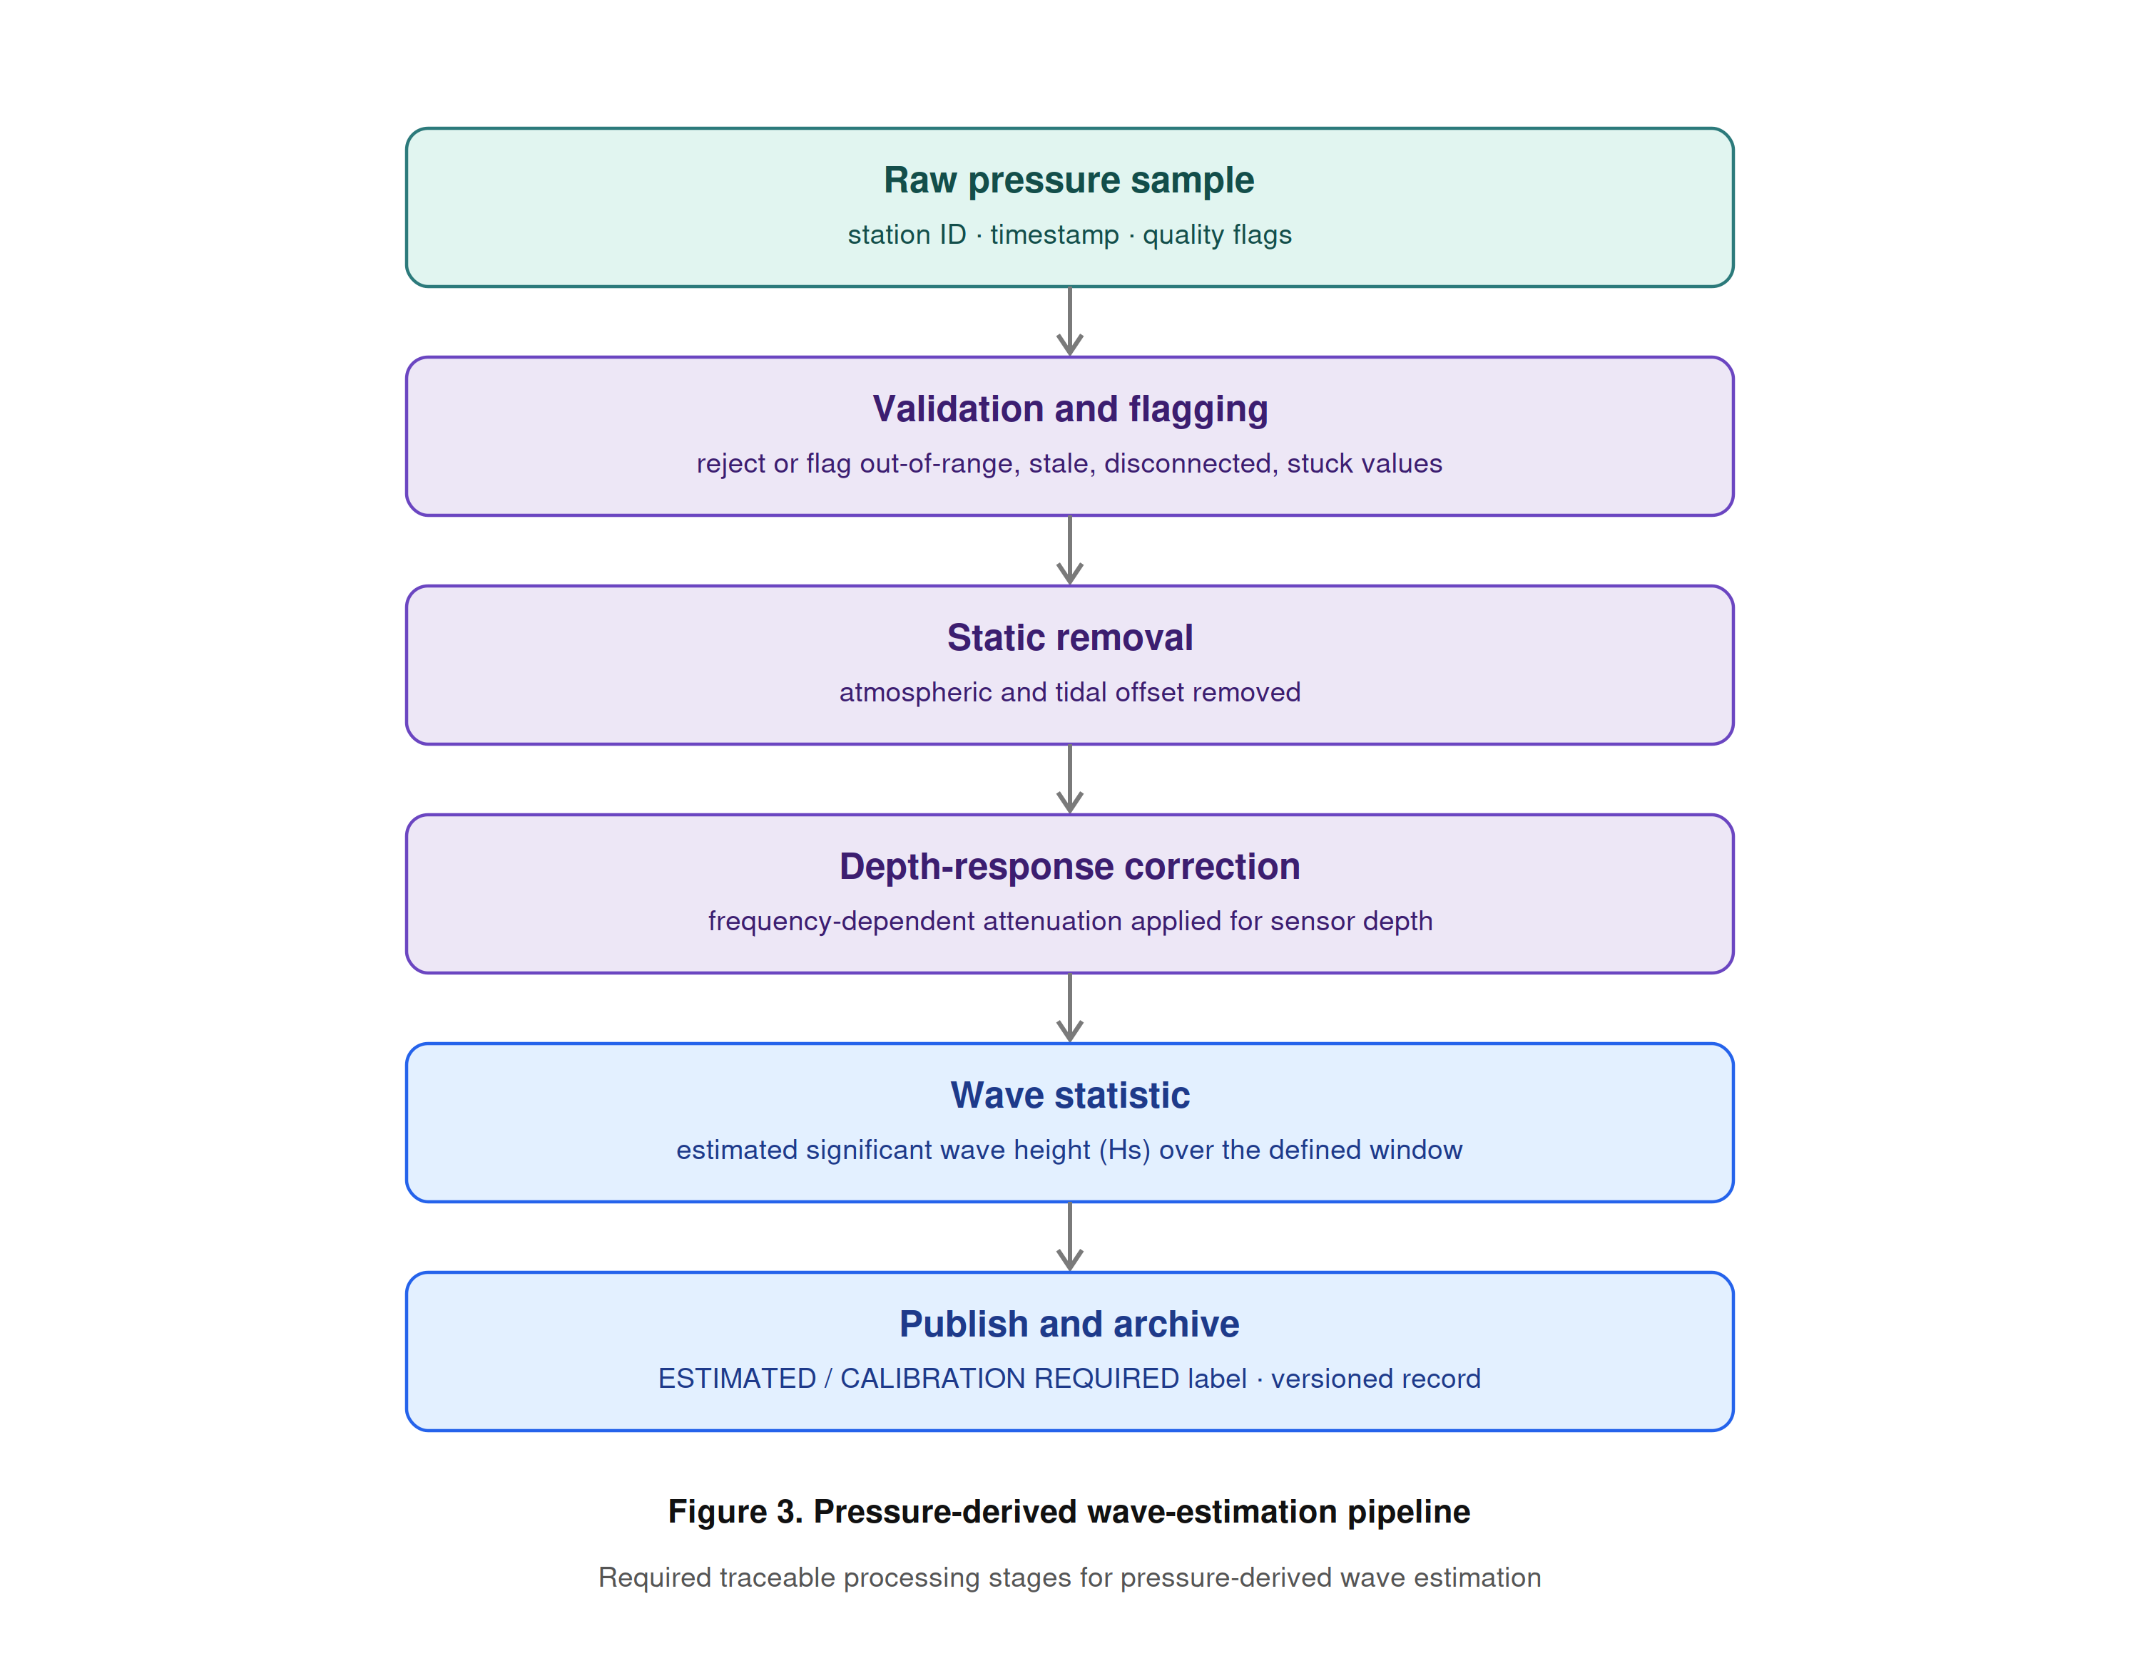
Figure 3. Pressure-derived wave-estimation pipeline
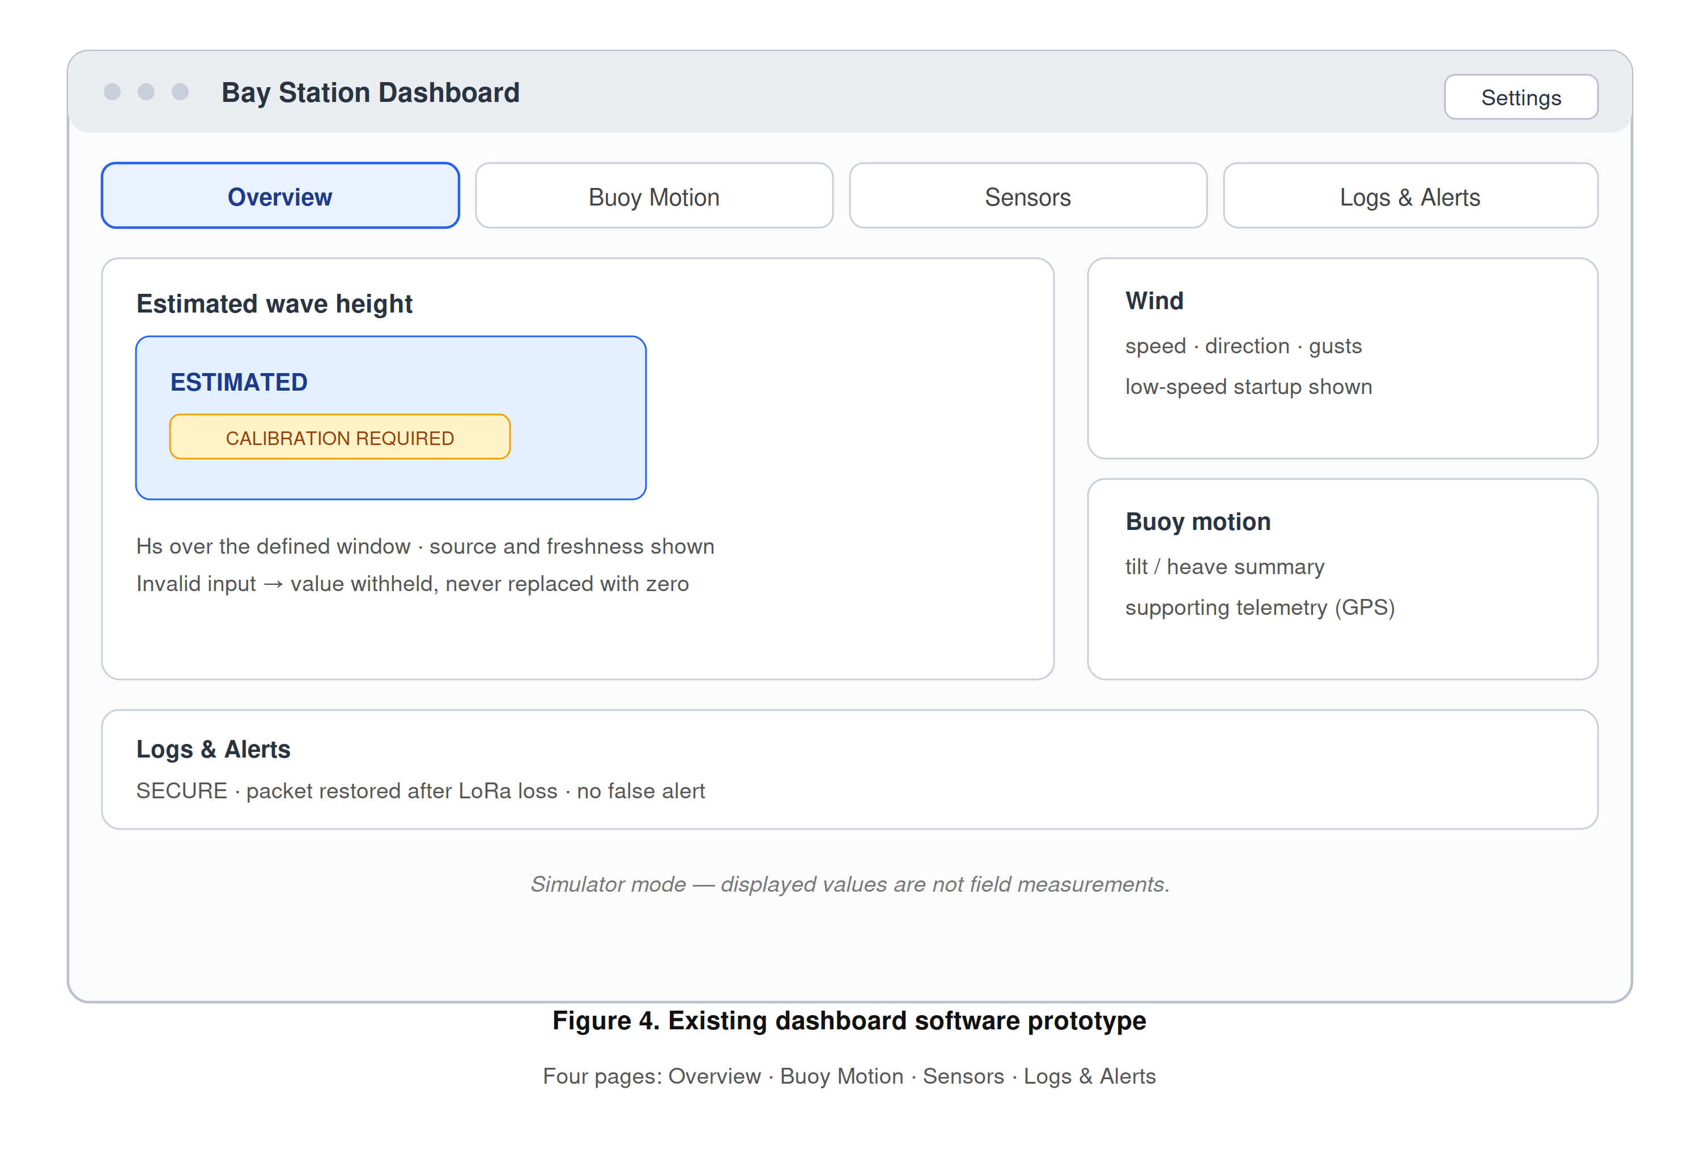
Figure 4. Existing dashboard software prototype
AI prediction procedure. One primary target is frozen — recommended as 10-minute-ahead estimated Hs — subject to adviser and stakeholder approval. Persistence and moving-average baselines are built before any linear, tree-based, GRU, or LSTM candidate is tested (Mo et al., 2024); data are split chronologically by deployment block or day, never by randomly mixing adjacent samples; and prediction is withheld whenever pressure input is invalid, stale, or uncalibrated, while monitoring continues if the AI component fails.
Energy, mechanical, and security procedures. A preliminary energy-budget worksheet (e.g., a 12.8 V, 20 Ah battery at 80% usable capacity against a 4 W average buoy load) is treated explicitly as a calculation, not a measurement, and is replaced by logged current data once hardware is frozen, consistent with energy-balance assessment for solar-powered IoT buoys (Wiranata & Widodo, 2026). The separate buoy and shore power boundaries are illustrated in Figure 5. The replacement mechanical design must pass buoyancy, freeboard, center-of-gravity, stability/righting, tower load, mooring, corrosion, cable strain, ingress, condensation, sensor exposure, antenna clearance, retrieval, and serviceability review. Physical security uses SECURE, WARNING, ALERT, and DISARMED states, with geofence radius, GPS-quality limits, persistence time, maintenance controls, and tamper debounce documented.
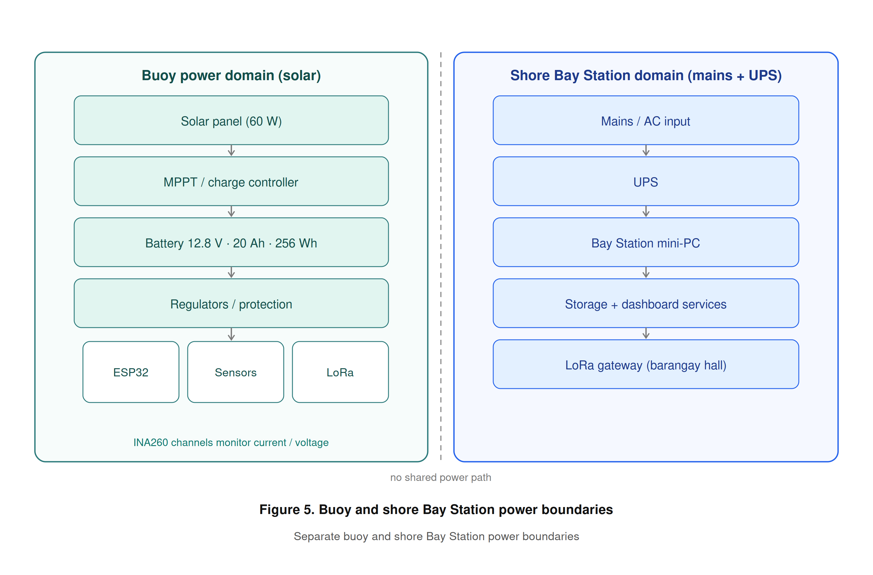
Figure 5. Buoy and shore Bay Station power boundaries

2.6 Testing and Evaluation
Evaluation is organized by area, each with primary metrics and an explicit release condition (Table 5). The evaluation is whole-system rather than component-by-component alone, in keeping with the central claim that honest integration and evidence is where the contribution lies (Figure 6).
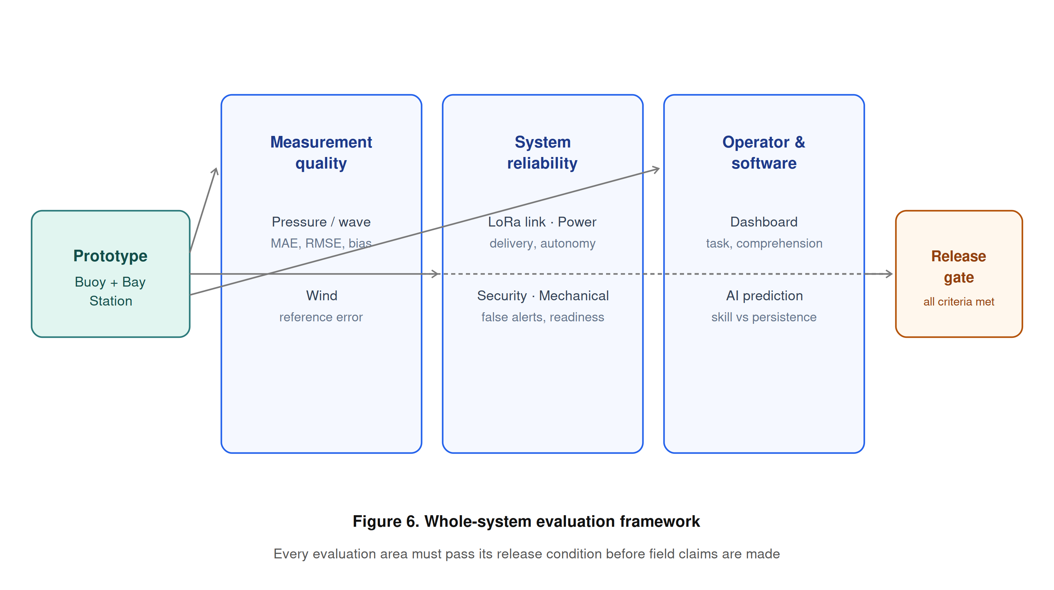
Figure 6. Whole-system evaluation framework
Table 5. Whole-System Evaluation Matrix
Area | Primary metrics / evidence | Release condition
Pressure / wave | MAE, RMSE, bias, repeatability, gaps, comparison plots | Defined wave statistic and accepted reference performance
Wind | Reference error, direction code, low-speed startup, repeatability | Acceptance limits approved and met
LoRa / backhaul | Packet delivery, latency, range, reconnect, duplicates, backlog recovery | Site path works under expected conditions
Power | Average/peak load, Wh/day, autonomy, reduced-sun recovery | Measured margin meets deployment target
Security | True/false alerts, detection delay, GPS scatter | False-alert behavior acceptable
Dashboard | Task completion, errors, time, comprehension, readability | Adviser-approved usability threshold met
AI | MAE/RMSE/bias, skill vs persistence, latency, availability | Improvement on untouched chronological test data
Mechanical | Stability, ingress, corrosion control, retrieval inspection | No unsafe or unresolved critical failure

Statistical treatment. Sensor accuracy is reported using mean absolute error (MAE), root-mean-square error (RMSE), and bias against the independent reference, with repeatability (standard deviation) and percentage error. Communication is summarized by packet-delivery ratio, latency, reconnection time, duplicate count, and backlog-recovery time. Prediction performance reports MAE, RMSE, bias, skill relative to persistence, inference time, model size, missing-input behavior, and error by sea-condition range, with uncertainty based on observed residuals rather than an arbitrary confidence percentage (Bekiryazıcı et al., 2025; Chan et al., 2026).
Test scenarios. Controlled scenarios verify fault and recovery behavior (Table 6), ensuring that abnormal conditions surface as explicit, logged states rather than as silent failures or fabricated values.
Table 6. Controlled Test Scenarios
ID | Scenario | Expected observable behavior
P-01 | Pressure disconnected or implausible | Wave estimate and AI withheld; fault logged; no fabricated zero
C-01 | LoRa link interrupted | ESP32 buffers timestamped packets; retransmits without duplicate insertion
I-01 | Bay Station Internet interrupted | Local ingestion, storage, prediction, dashboard, alerts continue
G-01 | GPS scatter near geofence boundary | WARNING persistence prevents immediate false ALERT
T-01 | Enclosure opened while armed | Persistent event produces logged ALERT; maintenance DISARMED distinct
A-01 | AI model unavailable | Measured/estimated monitoring remains operational; prediction shows unavailable
B-01 | Low battery / reduced sunlight | Power warning, safe operating policy, and recovery are logged
R-01 | Bay Station restart | Services start automatically and stored records remain intact

Usability testing. Evaluators are given realistic tasks — identify the current wave estimate, verify GPS/security state, find a stale sensor, acknowledge an alert, and export records. The testing records task completion, completion time, navigation errors, assistance required, and label comprehension, and collects readability and confidence ratings using an adviser-approved usability instrument and sample. Because GNSS-based observations are useful only with appropriate processing and reference comparison (Knight et al., 2021), position data are interpreted with fix quality and persistence, and an isolated coordinate is never by itself treated as theft. The research instrument undergoes expert validation with a certificate of validation obtained before data gathering.

2.7 Ethical Considerations
Site, permits, and safety. Deployment requires written permission from the responsible site authority (e.g., the barangay or local government unit) and navigational and environmental review. Field work observes safe battery and electrical handling, defined weather limits, retrieval planning, and unambiguous prototype labeling so the public cannot mistake the buoy for an official installation.
Human participants. Usability participants — including older or non-technical operators — provide informed consent, and only the minimum necessary data are collected. Participants may withdraw at any time, and no personally identifying information is published without permission.
Public safety and honesty. The system must never issue or imply official warnings; operators are directed to PAGASA and competent authorities for all safety decisions (PAGASA, n.d.). The thesis maintains strict vocabulary discipline: pressure-derived output is presented only as estimated wave height, the AI output only as a research prediction, and simulator results are never described as physical measurements.
Data privacy and security. GPS locations are disclosed only to authorized users where a deployment partner regards them as sensitive. Cybersecurity controls include per-device identity, replay/duplicate protection, least-privilege operator access, TLS for Internet traffic, and audit records, protecting both the data and the individuals and communities associated with the deployment site.
Research integrity and environmental care. Intellectual honesty is enforced through version control of firmware, schemas, algorithms, and models; full retention of raw and processed data with quality metadata; and explicit documentation of limitations. Field activities minimize environmental disturbance, and all retrieved hardware and batteries are handled and disposed of responsibly.

